AAYUSH PATIL - 56

MLDL EXPERIMENT 8

AIM -
Design and train a Convolutional Neural Network (CNN) on image datasets

DATASET SOURCE -

https://github.com/zalandoresearch/fashion-mnist

DATASET DESCRIPTION -

To design and train a Convolutional Neural Network (CNN) for image classification using the Fashion-MNIST dataset.

Objective
- To understand CNN architecture
- To classify images of clothing items
- To improve accuracy using convolutional layers
- To visualize performance using graphs
Fashion-MNIST is a dataset of clothing images created by Zalando. It is used for training machine learning models for image classification tasks.
Dataset Size
- Training images: 60,000
- Testing images: 10,000
- Total: 70,000 images

Image Details
- Size: 28 × 28 pixels
- Type: Grayscale (1 channel)
- Pixel values: 0 to 255

Number of Classes (10 Categories)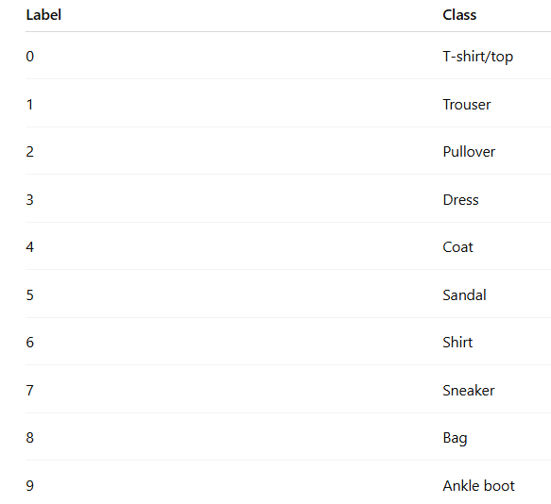

Dataset Type
- Structured: Image data
- Learning Type: Supervised
- Problem Type: Multi-class classification

THEORY -

1. Introduction to CNN
CNN (Convolutional Neural Network) is a deep learning model specially designed for image processing.
Unlike ANN:
- ANN → treats image as flat data
- CNN → preserves image structure

2. CNN Architecture

2.1. Convolution Layer
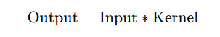
- Extracts features (edges, textures)

2.2. Activation Function (ReLU)

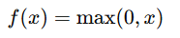

2.3. Pooling Layer
- Reduces image size
- Keeps important features
Types:
- Max Pooling
- Average Pooling

2.4. Flatten Layer
- Converts 2D → 1D

2.5. Fully Connected Layer
- Final classification

2.6. Output Layer (Softmax)
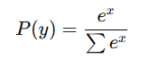
- Gives probability for 10 classes

3. Working of CNN
- Input image (28×28)
- Convolution extracts features
- Pooling reduces size
- Flatten converts to vector
- Dense layer classifies
- Output → predicted class

8. Output Explanation
- Accuracy → how well model predicts
- Confusion Matrix → correct vs wrong predictions
- Accuracy Graph → learning progress
- Loss Graph → error reduction
- Sample Images → prediction visualization

9. Advantages of CNN
- Best for image data
- High accuracy
- Automatic feature extraction
- Handles spatial data

10. Limitations
- Requires high computation
- Needs large data
- Hard to interpret

11. Applications
- Image recognition
- Face detection
- Medical imaging
- Self-driving cars
- Fashion classification

CODE -

# Step 1: Import Libraries
import tensorflow as tf
from tensorflow.keras import layers, models
import matplotlib.pyplot as plt
import numpy as np
from sklearn.metrics import confusion_matrix, classification_report
import seaborn as sns

# Step 2: Load Dataset
fashion_mnist = tf.keras.datasets.fashion_mnist
(X_train, y_train), (X_test, y_test) = fashion_mnist.load_data()

# Step 3: Normalize Data
X_train = X_train / 255.0
X_test = X_test / 255.0

# Reshape for CNN (add channel)
X_train = X_train.reshape(-1,28,28,1)
X_test = X_test.reshape(-1,28,28,1)

# Step 4: Build CNN Model
model = models.Sequential()

model.add(layers.Conv2D(32, (3,3), activation='relu', input_shape=(28,28,1)))
model.add(layers.MaxPooling2D((2,2)))

model.add(layers.Conv2D(64, (3,3), activation='relu'))
model.add(layers.MaxPooling2D((2,2)))

model.add(layers.Flatten())

model.add(layers.Dense(128, activation='relu'))
model.add(layers.Dense(10, activation='softmax'))

# Step 5: Compile Model
model.compile(optimizer='adam',
loss='sparse_categorical_crossentropy',
metrics=['accuracy'])

# Step 6: Train Model
history = model.fit(X_train, y_train, epochs=10, validation_data=(X_test, y_test))

# Step 7: Evaluate
test_loss, test_acc = model.evaluate(X_test, y_test)
print("Test Accuracy:", test_acc)

# Step 8: Predictions
y_pred = model.predict(X_test)
y_pred_classes = np.argmax(y_pred, axis=1)

# Step 9: Confusion Matrix
cm = confusion_matrix(y_test, y_pred_classes)

plt.figure(figsize=(6,5))
sns.heatmap(cm, annot=True, fmt='d')
plt.title("Confusion Matrix")
plt.show()

# Step 10: Accuracy Graph
plt.plot(history.history['accuracy'], label='Train Accuracy')
plt.plot(history.history['val_accuracy'], label='Val Accuracy')
plt.legend()
plt.title("Accuracy Graph")
plt.show()

# Step 11: Loss Graph
plt.plot(history.history['loss'], label='Train Loss')
plt.plot(history.history['val_loss'], label='Val Loss')
plt.legend()
plt.title("Loss Graph")
plt.show()

# Step 12: Sample Predictions
class_names = ['T-shirt','Trouser','Pullover','Dress','Coat',
'Sandal','Shirt','Sneaker','Bag','Ankle Boot']

plt.figure(figsize=(10,5))
for i in range(10):
plt.subplot(2,5,i+1)
plt.imshow(X_test[i].reshape(28,28), cmap='gray')
plt.title(class_names[y_pred_classes[i]])
plt.axis('off')
plt.show()

OUTPUT -

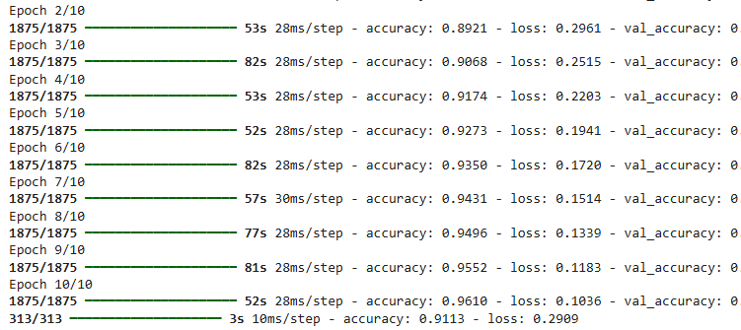
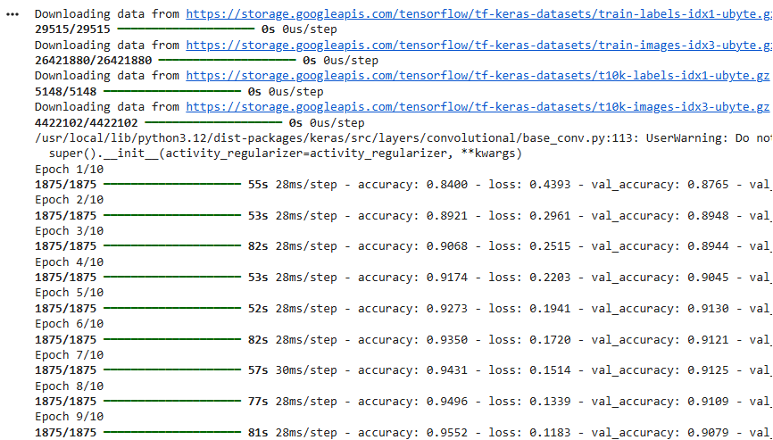
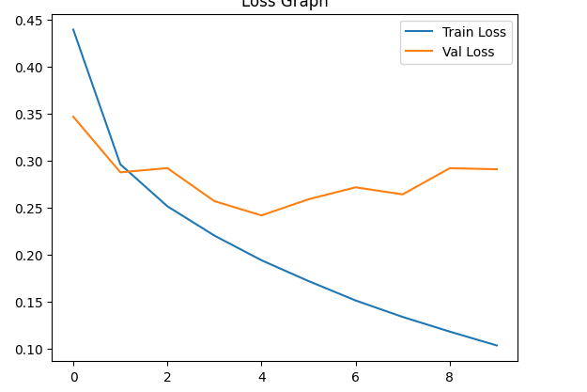
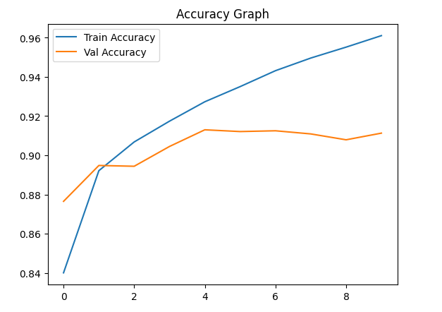
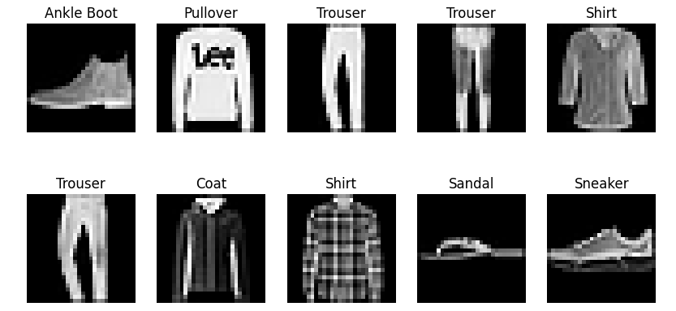

12. Conclusion
In this experiment, a Convolutional Neural Network (CNN) was successfully designed, implemented, and trained using the Fashion-MNIST dataset for the task of image classification. The primary objective was to enable the model to automatically identify and classify different categories of clothing items such as T-shirts, shoes, bags, and dresses based on image input.
The CNN model was able to learn hierarchical features from the images, starting from basic patterns such as edges and textures in the initial layers, to more complex shapes and object-specific features in deeper layers. This automatic feature extraction capability of CNN makes it significantly more powerful than traditional Artificial Neural Networks for image-based tasks.
During the training phase, the model was optimized using forward propagation and backpropagation techniques, along with the Adam optimizer, to minimize the loss function and improve prediction accuracy. The performance of the model was evaluated using various metrics such as accuracy and confusion matrix, and visualized through graphs including accuracy vs epochs and loss vs epochs. These graphs demonstrated that the model effectively learned from the dataset, as indicated by increasing accuracy and decreasing loss over time.
The final results showed that the CNN model achieved a high level of accuracy in classifying unseen test images, proving its effectiveness in handling real-world image classification problems. Additionally, the confusion matrix provided insights into the classes where the model performed well and where minor misclassifications occurred.
Overall, this experiment highlighted the importance and efficiency of CNNs in image processing applications. It demonstrated how deep learning models can be trained to recognize patterns in visual data and make intelligent predictions. The knowledge gained from this experiment can be applied to various real-world domains such as medical imaging, facial recognition, autonomous driving, and fashion recommendation systems.

